**Challenge w**

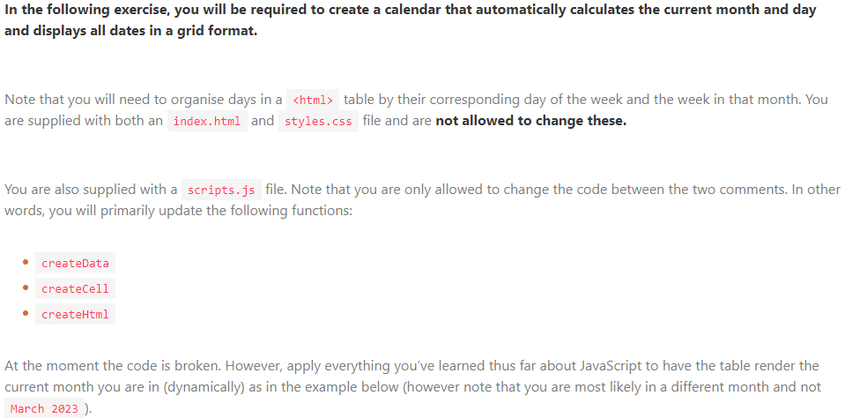

<!-- index.html -->

<!DOCTYPE html>

<html lang="en">

<head>

<meta charset="UTF-8">

<meta http-equiv="X-UA-Compatible" content="IE=edge">

<meta name="viewport" content="width=device-width, initial-scale=1.0">

<title>Calendar</title>

<link rel="stylesheet" href="/styles.css">

<script src="/loops.js" defer type="module"></script>

</head>

<body>

<h1 data-title>Loading...</h1>

<table class="table">

<thead>

<tr>

<th class="table__cell table__cell_heading">Week</th>

<th class="table__cell table__cell_heading">Sun</th>

<th class="table__cell table__cell_heading">Mon</th>

<th class="table__cell table__cell_heading">Tue</th>

<th class="table__cell table__cell_heading">Wed</th>

<th class="table__cell table__cell_heading">Thu</th>

<th class="table__cell table__cell_heading">Fri</th>

<th class="table__cell table__cell_heading">Sat</th>

</tr>

</thead>

<tbody data-content></tbody>

</table>

</body>

</html>

________________________________________________________________________________________  
  
/* styles.css */

* {

box-sizing: border-box;

}

body {

margin: 0;

display: flex;

align-items: center;

justify-content: center;

min-height: 100vh;

flex-direction: column;

font-family: sans-serif;

background: rgba(0, 0, 0, 0.1);

color: rgba(0, 0, 0, 0.9);

}

.table {

box-shadow: rgba(0, 0, 0, 0.24) 0px 3px 8px;

white-space: nowrap;

border-spacing: 0;

border-radius: 8px;

overflow: hidden;

background: rgba(255, 255, 255, 1);

}

.table__cell {

width: 5rem;

height: 5rem;

align-items: center;

justify-content: center;

border-collapse: collapse;

border-right: 1px solid rgb(0, 0, 0, 0.1);

border-bottom: 1px solid rgb(0, 0, 0, 0.1);

text-align: center;

font-weight: bold;

}

.table__cell_heading {

border-bottom: 1px solid rgb(0, 0, 0, 1);

background: rgba(0, 0, 0, 0.9);

color: white;

}

.table__cell_today {

color: blue;

background: rgba(0, 0, 255, 0.1);

}

.table__cell_sidebar {

color: rgba(0, 0, 0, 0.8);

border-right: 1px solid rgb(0, 0, 0, 0.2);

font-weight: normal;

font-size: 0.8rem;

}

.table__cell_weekend {

font-weight: normal;

color: rgba(0, 0, 0, 0.6);

}

.table__cell_alternate {

background: rgba(0, 0, 0, 0.05);

}

________________________________________________________________________________________  
  
// scripts.js

// Do not edit HTML or CSS

const MONTHS = [

'January',

'February',

'March',

'April',

'May',

'June',

'July',

'August',

'September',

'October',

'November',

'December',

]

const getDaysInMonth = (date) => new Date(date.getFullYear(), date.getMonth() + 1, 0).getDate()

// Only edit below

const createArray = (length) => {

const result = []

for (let = ; i < length; i) {

result.push()

}

return result

}

const createData = () > {

const current = new ()

current.set(1)

const startDay = current.get()

const daysInMonth = getDaysInMonth(current)

const weeks = createArray(5)

const days = ()

const result = []

for (const weekIndex of weeks) {

result.push({

week: weekIndex + 1,

days: []

})

for (const of ) {

const day = (dayIndex - startDay) : (weekIndex * 7) 1

const isValid = day > 0 && day <= daysInMonth

result[weekIndex].days.push({

dayOfWeek: dayIndex + 1,

value: isValid ? day : '',

})

}

}

return result

}

const addCell = (existing, classString, value) => {

const result = /* html */ `

${}

<td class="${classString}">

&nbsp;${value}&nbsp;

</td> `

return result

}

const createHtml = (data) => {

let result = ''

for (const { week, } of ) {

let inner = ""

inner = addCell(inner, 'table__cell table__cell_sidebar', `Week ${week}`)

(const { dayOfWeek, value } of days) {

const isToday = new Date().getDate() === value

const isWeekend = dayOfWeek === | dayOfWeek ===

const isAlternate = week % 2 === 0

let classString = 'table__cell'

if () classString = `${} table__cell_`

if () classString = `${} table__cell_`

if () classString = `${} table__cell_`

inner = addCell()

}

result = `

${result}

<tr>${inner}</tr>

`

}

return result

}

// Only edit above

const current = new Date()

document.querySelector('[data-title]').innerText = `${MONTHS[current.getMonth()]} ${current.getFullYear()}`

const data = createData()

document.querySelector('[data-content]').innerHTML = createHtml(data)